**Employee Attrition Analysis**

**AIM**

The aim of analysing an employee attrition dataset is to identify the key factors that contribute to why employees leave an organization, such as job satisfaction, work environment, compensation, and career growth opportunities. By developing predictive models, the analysis seeks to pinpoint employees who are at a higher risk of leaving, enabling organizations to take proactive measures to retain valuable talent. Additionally, the analysis provides data-driven insights to inform and optimize human resource strategies aimed at reducing turnover and enhancing employee retention. Ultimately, this analysis supports decision-making processes that foster a positive work environment and improve employee satisfaction.

**DATA OVERVIEW**

This analysis is based on a dataset containing 1,676 rows, where 199 employees experienced attrition (attrition = "Yes") and 1,477 employees did not experience attrition (attrition = "No").

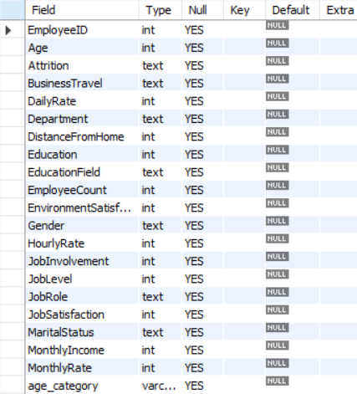

**INSIGHTS**

The key factors influencing attrition are examined below:

**1. Department-Wise Attrition:**

* **Highest Attrition:** The Maternity department has the highest attrition rate, indicating that employees in this department are more likely to leave the organization.
* **Lowest Attrition:** The Neurology department has the lowest attrition rate, suggesting that employees in this department are more satisfied or face fewer issues that lead to leaving the organization.

**2. Age Group and Attrition:**

* **Age Group with Highest Attrition:** Young employees, particularly those below 30 years of age, show the highest attrition rates. This could be due to various factors like career exploration, better opportunities, or dissatisfaction with their current roles.

**3. Gender and Attrition:**

* **Gender with Higher Attrition:** Males experience higher attrition rates compared to females. This might be influenced by factors such as job satisfaction, work-life balance, or career progression opportunities.

**4. Attrition Based on Distance from Home:**

* **Distance Impact:** Employees living closer to the workplace (smaller distance from home) tend to have higher attrition rates. This could indicate that proximity does not necessarily lead to job satisfaction and may highlight other factors contributing to their decision to leave.

**5. Attrition and Environment Satisfaction:**

* **Environment Satisfaction Impact:** Employees with lower environmental satisfaction are more likely to leave the organization. This underscores the importance of a positive and supportive work environment in retaining employees.

**6. Job Role and Attrition:**

* **Highest Attrition in Job Role:** Nurses have the highest attrition rate among all job roles, suggesting that this role may involve challenges such as high stress, workload, or dissatisfaction.
* **Lowest Attrition in Job Role:** The Administrative roles have the lowest attrition rate, indicating higher job satisfaction or stability in these positions.

**7. Marital Status and Attrition:**

* **Attrition Based on Marital Status:** Single employees are more likely to experience attrition. This could be due to a variety of factors such as the pursuit of better career opportunities, flexibility, or fewer familial obligations.

**8. Salary and Attrition:**

* **Salary Overview:**
  + **Maximum Salary:** $19,999
  + **Minimum Salary:** $1,009
  + **Average Salary:** $6,500
* **Salary Impact on Attrition:** Employees with lower salaries are more likely to leave the organization, especially if they are young. On the other hand, employees with higher salaries tend to have lower attrition rates, and they are often older, indicating a correlation between salary, age, and job stability.

**Conclusion:**

Attrition in the organization is influenced by a variety of factors including salary, age, department, distance from home, and job satisfaction. By addressing wage disparities, improving work conditions in high-attrition departments, and providing support for employees with long commutes, the company can significantly improve retention rates. Additionally, focusing on career development for younger employees and improving overall job satisfaction will help reduce turnover across the board.By combining these insights, the organization can take a strategic approach to reducing attrition and fostering a more satisfied and stable workforce.